## rasa basic folder

https://drive.google.com/file/d/1S6JUXe-jfVLGJn7wlBWsppjl7wUwTpz8/view?usp=sharing

## list modules

pip freeze

## list envs

conda info --envs

## delete envs(Not Needed)

conda remove -n rasa --all

## create new env

conda create -n rasa python==3.7.9

## activate env

conda activate rasa

## find latest rasa

pip install rasa

pip install rasa[spacy]

### only if getting space 3.0 dep error

pip install --upgrade spacy==2.2.4

## download the pre-trained models (Admin)

activate rasa

python -m spacy download en_core_web_md

python -m spacy link en_core_web_md en

## check Installation

rasa train nlu

## Rasa config

https://rasa.com/docs/rasa/tuning-your-model/

https://rasa.com/docs/rasa/policies

language: "en"

pipeline:

- name: SpacyNLP

- name: SpacyTokenizer

- name: SpacyFeaturizer

- name: RegexFeaturizer

- name: LexicalSyntacticFeaturizer

- name: CountVectorsFeaturizer

- name: CountVectorsFeaturizer

analyzer: "char_wb"

min_ngram: 1

max_ngram: 4

- name: DIETClassifier

epochs: 100

- name: EntitySynonymMapper

- name: ResponseSelector

epochs: 100

policies:

- name: MemoizationPolicy

- name: TEDPolicy

max_history: 5

epochs: 200

- name: RulePolicy

### rasa domain

actions:

- action_search_restaurants

- check_location

- utter_ask_cuisine

- utter_ask_howcanhelp

- utter_ask_location

- utter_default

- utter_goodbye

- utter_greet

entities:

- cuisine

- location

- people

- price

intents:

- greet

- restaurant_search

- affirm

- goodbye

- stop.

responses:

utter_ask_cuisine:

- buttons:

- payload: Chinese

title: Chinese

- payload: Italian

title: Italian

- payload: South Indian

title: South Indian

- payload: North Indian

title: North Indian

text: what kind of cuisine would you like?

utter_ask_howcanhelp:

- text: how can I help you?

utter_ask_location:

- text: In what location?

utter_default:

- text: i cannot understand

utter_goodbye:

- text: goodbye :(

- text: Bye-bye

utter_greet:

- text: hey there! How may i help you

- text: Hi, How can I help you!

- text: Hey, How is it going How May I help you Today

session_config:

carry_over_slots_to_new_session: true

session_expiration_time: 0

slots:

cuisine:

type: text

location:

type: text

check_op:

type: bool

## train nlu

rasa train nlu

## test nlu

rasa shell nlu

## train core

rasa train

## start action server

rasa run actions

## create new data

rasa interactive

## rule-based action prediction

https://rasa.com/docs/rasa/rules

##mail send

https://www.tutorialspoint.com/send-mail-from-your-gmail-account-using-python

## check zomato user key

## https://drive.google.com/file/d/1z9a-VShW7K619B6QEm5ezAwrTgtF15fM/view?usp=sharing

### flask

#Oauth

https://docs.microsoft.com/en-us/azure/bot-service/bot-service-channel-connect-slack?view=azure-bot-service-4.0&tabs=abs

app_mentions:read

channels:history

channels:read

chat:write

groups:history

groups:read

im:history

mpim:history

#connector

https://forum.rasa.com/t/slack-integration-500-error/12318/10

rasa run actions & rasa run --connector slack

#ngrok

ngrok http 5055

https://bd7f2adc03ec.ngrok.io/webhooks/slack/webhook

## rasa slack doc

https://rasa.com/docs/rasa/user-guide/connectors/slack/

############################################################

NLU Training

Build action for BOT

Creating more stories

Deplyment options

Send mail

Open Zomato.csv

Two differnt model/

1) classification

2) sequence tagging

What is the intention of tasks

Always itend is not sufficient to find the result.

Then we need more information

Intent : restaurant_search

Intent clasification

Entity extraction

NLG (natural language generation)

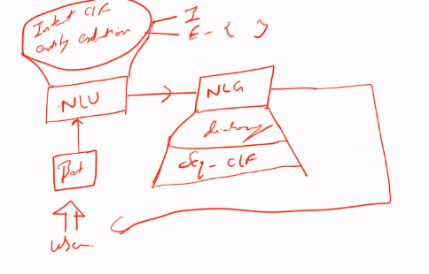

Actions.py

Stories.md

Domain.yml

Place cusine and filer

Sorting based upon rating

Go file one by one

NLU –

1. Domain.yml – intent and entity it’s universe of the bot
2. Config.yml – pipeline and policies
   1. EntitySynonymMapper is used to find synonums
3. Nlu.md

(entity)[entity type]

Rasa.com/docs/rasa/tuning-our-model

https://rasa.com/docs/rasa/tuning-your-model/

How to define training data-

Spacy featurizer

Rasa 2.2.4

python -m spacy link en_core_web_md en

rasa train nlu

rasa shell nlu

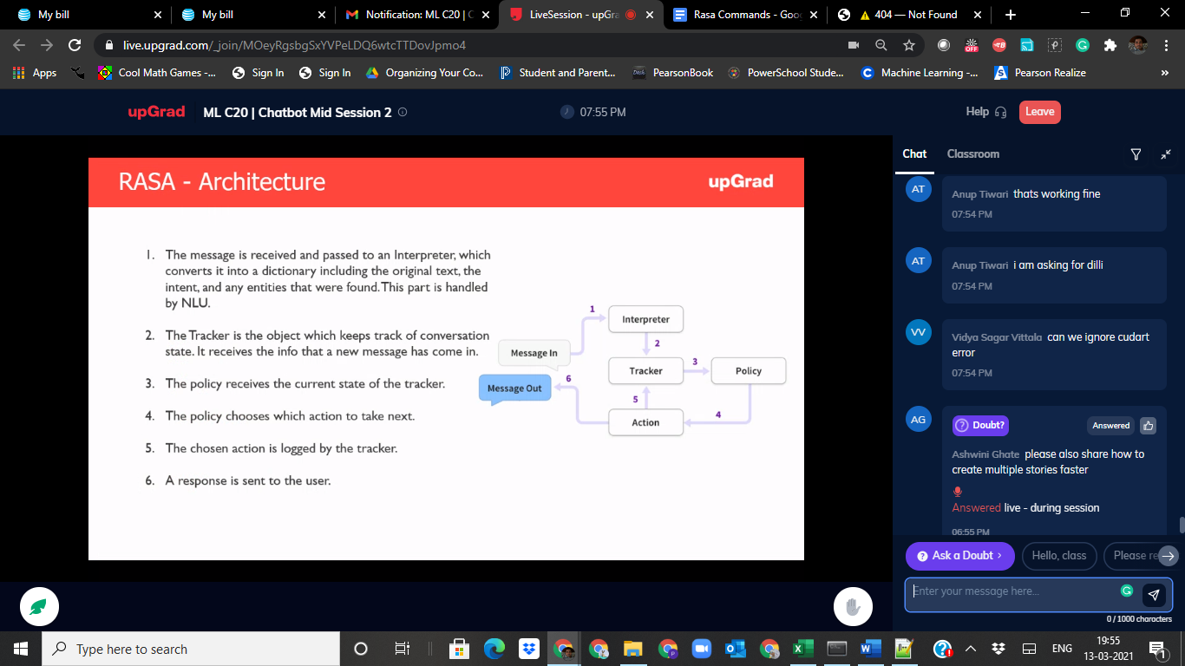

Action terminal

Shell terminal

Tracker tracks all conversation

Rasa train

Rasa shell

Rasa run actions

Define a new action in domain.yml

Modeify actions.py

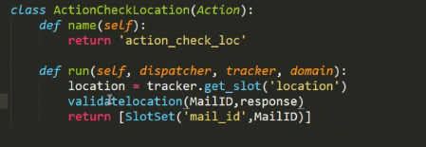

Create another slot in domain.yml

Create a new stories.md

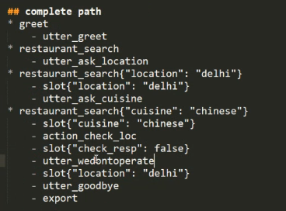

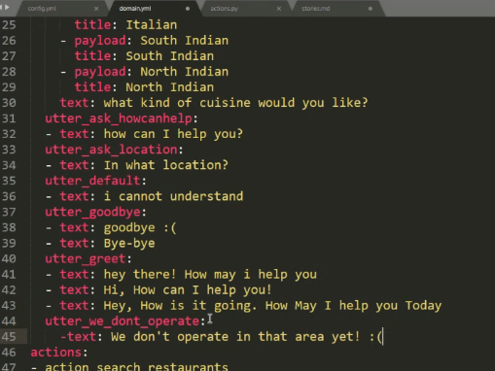



Stories are training data

Rasa intractive

Update .yml to .md

Find synonyms

1. Update synonyms in nlu.md
2. Show the message in case of city not found “We don’t operate in this area yet.”
3. If location doesn’t have 5 restaurant then show message as above.
4. Ask for cuisine
5. Question to ask “Cost for 2 people”.
6. Return restaurant list based upon rating descending order.
7. Ask for email
8. Send Email

- utter_ask_price

- slot{"price": "Lesser than Rs. 300"}

* restaurant_search{"price": "Lesser than Rs. 300"}

email_confirmation:

type: bool

email:

type: text

[Upgradpr@gmail.com](mailto:Upgradpr@gmail.com)

Pravin1234

Advanced

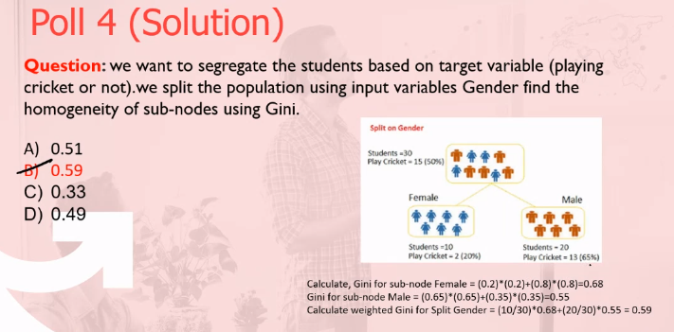

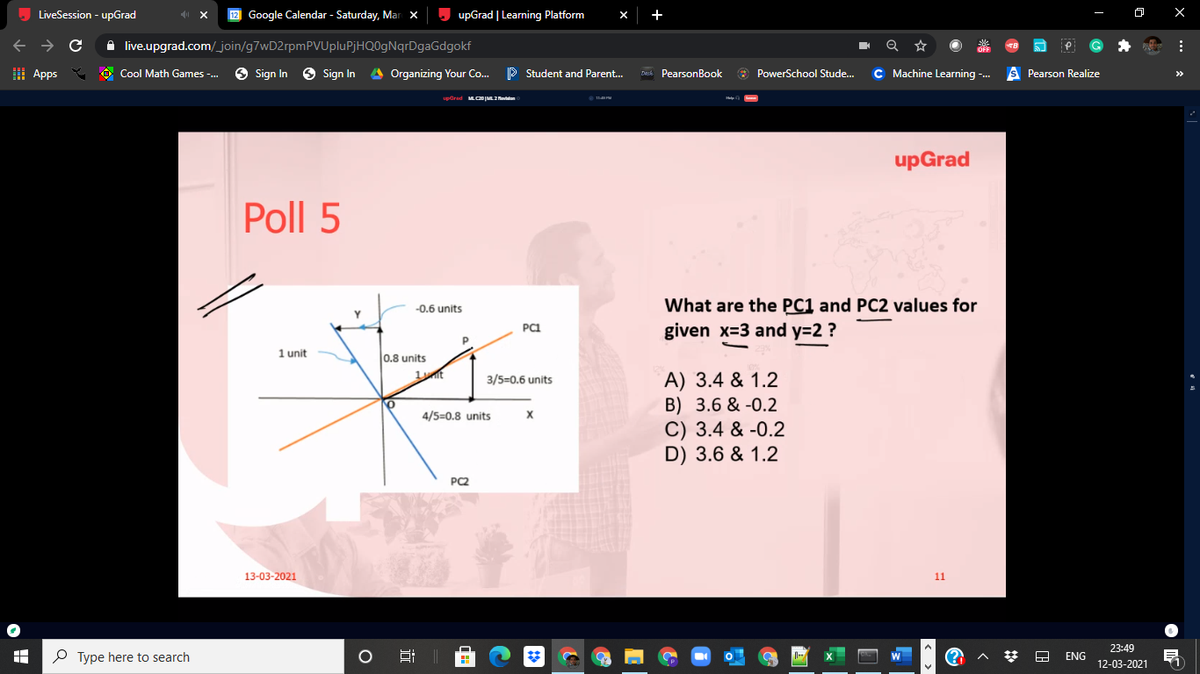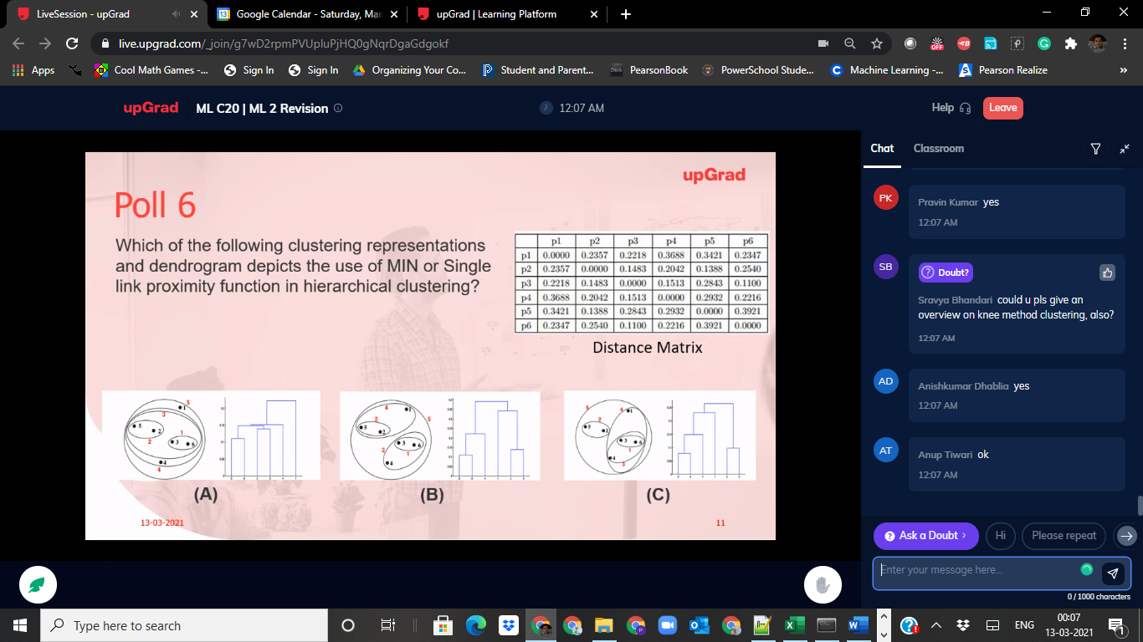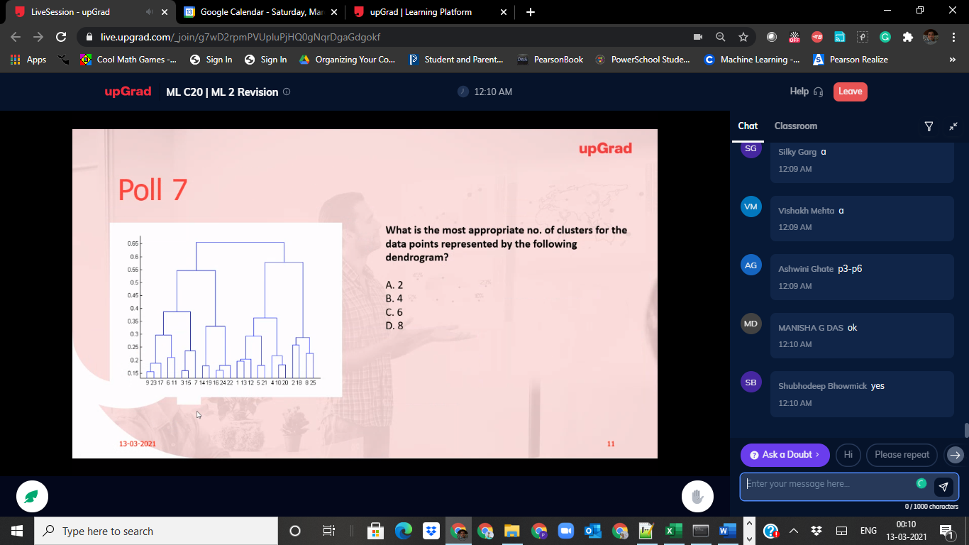

## complete path 4

* greet

- utter_greet

* restaurant_search

- utter_ask_location

* restaurant_search{"location": "delhi"}

- action_check_loc

- slot{"check_resp":false}

- utter_nonoperable_location

* restaurant_search{"cuisine": "chinese"}

- utter_ask_price

* restaurant_search{"price": "Lesser than Rs. 300"}

- action_search_restaurants

- utter_ask_email

* email_confirmation_intent{"email_confirmation": "NO"}

- action_confirm_email

- slot{"check_email":false}

- utter_goodbye

- export